Competition Analysis:
The below graph showcases the Competition analysis w.r.t technological innovation and market reach.

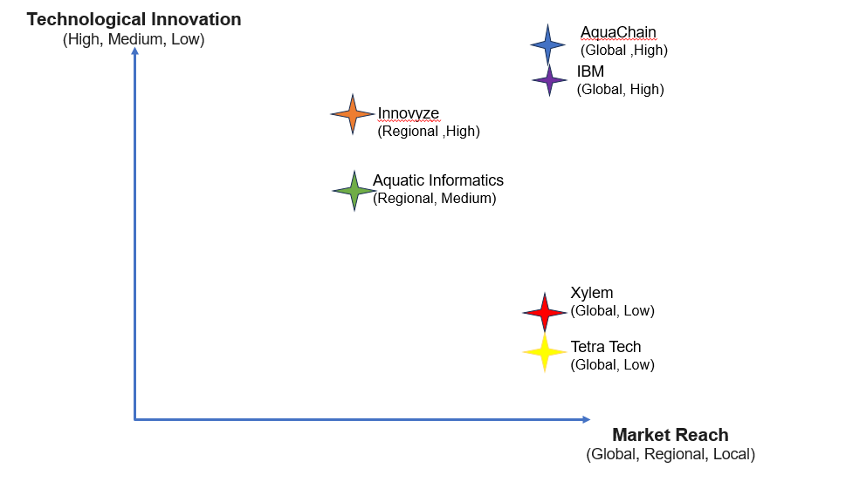

Detailed analysis of potential competitors with market place ranking, Strengths, and Weaknesses
- Aquatic Informatics:
  - Market Ranking: Top 5 in water data management software solutions.
  - Description: Aquatic Informatics specializes in developing software solutions for water data management, including data acquisition, analysis, and reporting. Their products are used by water agencies, environmental organizations, and research institutions worldwide.
  - Strengths:
    - Advanced data management capabilities, including real-time monitoring and analytics.
    - User-friendly interface and customizable features to meet diverse customer needs.
    - Strong customer support and training programs.
  - Weaknesses:
    - Limited market reach compared to larger competitors.
    - Potential scalability challenges for very large datasets or complex systems.
- Innovyze:
  - Market Ranking: Top 3 in water infrastructure modeling and simulation software.
  - Description: Innovyze offers a range of software solutions for water and wastewater infrastructure planning, design, and management. Their products are widely used by engineering firms, utility companies, and government agencies to optimize water systems performance and resilience.
  - Strengths:
    - Robust modeling and simulation capabilities for complex water systems.
    - Integration with Geographic Information Systems (GIS) for spatial analysis.
    - Continuous innovation and updates to meet evolving industry needs.
  - Weaknesses:
    - Higher learning curve for users unfamiliar with modeling software.
    - Pricing may be a barrier for smaller organizations or projects.

- Xylem Inc.:
  - Market Ranking: Top 2 globally in water technology solutions.
  - Description: Xylem Inc. offers a wide range of water technology products and services, including pumps, filtration systems, and analytics solutions. They serve various sectors, including utilities, industrial, commercial, and residential customers, with a focus on water efficiency and sustainability.
  - Strengths:
    - Diverse product portfolio covering various aspects of water management and treatment.
    - Global presence and established brand reputation.
    - Strong emphasis on research and development for innovative solutions.
  - Weaknesses:
    - Large-scale operations may lead to bureaucracy and slower decision-making.
    - Competition from specialized software providers in the water data management sector.
- IBM’s Water Management:
  - Market Ranking: Leader in providing advanced analytics and IoT-enabled water management solutions.
  - Description: IBM offers water management solutions powered by advanced analytics, artificial intelligence (AI), and Internet of Things (IoT) technologies. Their solutions enable water utilities and organizations to optimize operations, reduce water loss, and improve resource efficiency.
  - Strengths:
    - Cutting-edge analytics capabilities for predictive maintenance and risk management.
    - Integration with IoT sensors and data sources for real-time monitoring.
    - Customizable solutions tailored to specific customer needs and challenges.
  - Weaknesses:
    - High initial investment and implementation costs.
    - Potential integration challenges with existing systems and infrastructure.
- Tetra Tech:
  - Market Ranking: Top 5 consulting and engineering firms in the water sector.
  - Description: Tetra Tech provides consulting, engineering, and technical services for water and environmental projects worldwide. Their expertise includes water resources management, environmental planning, and infrastructure development, serving clients in the public and private sectors.
  - Strengths:
    - Comprehensive suite of services covering all stages of water project development.
    - Extensive experience and expertise in regulatory compliance and permitting.
    - Global presence and established reputation for quality and reliability.
  - Weaknesses:
    - Project-based revenue models may lead to revenue fluctuations.
    - Dependency on government contracts and funding for large-scale projects.

